Chuckler’s Bean
1. Introduction:
This documentation provides an overview of Chuckler’s Bean, a coffee beans website, focusing on its key components, functionalities, and design aspects. The Chucklers Bean website aims to offer a seamless user experience for coffee enthusiasts to explore and purchase high-quality coffee beans. This documentation outlines the essential features, designing and implementation details of the website.
2. Technologies Used:
The Chucklers Bean website is built using the following technologies:
HTML5: Used for structuring the website's content and elements.
CSS: Utilized for styling and enhancing the visual presentation of the website.
JavaScript: Employed for interactive functionalities and dynamic behavior.
3. Key Features
a. Product Listing:
- Displays a list of coffee beans available for purchase.
- Provides essential details such as the product name, and price.
- Allows users to buy on a product.
b. User Account Sign Up and Sign In:
- Allows new users to create an account by providing necessary information.
- Provides a sign-in option for existing users to access their account.
3. Mock-ups
For the creation of mock-ups, the Chucklers Bean website utilized Canva, a popular online design tool. Canva offers a user-friendly interface and a wide range of templates, graphics, and elements to create visually appealing designs. The mock-ups created in Canva helped in visualizing and planning the website's layout, color schemes, and overall aesthetics before implementation.
4. Design and User Interface
The Chucklers Bean website employs a clean and user-friendly design to enhance the shopping experience. The design considerations include:
a. Branding and Visuals:
Reflects the Chucklers Bean brand through appropriate colors, typography, and imagery.
Utilizes high-quality product images to showcase the coffee beans' appearance and appeal to users.

b. Layout and Structure:
Creates a simple and intuitive layout that allows users to navigate and find products easily. Ensures responsive design to provide a consistent experience across different devices.

LOGO:


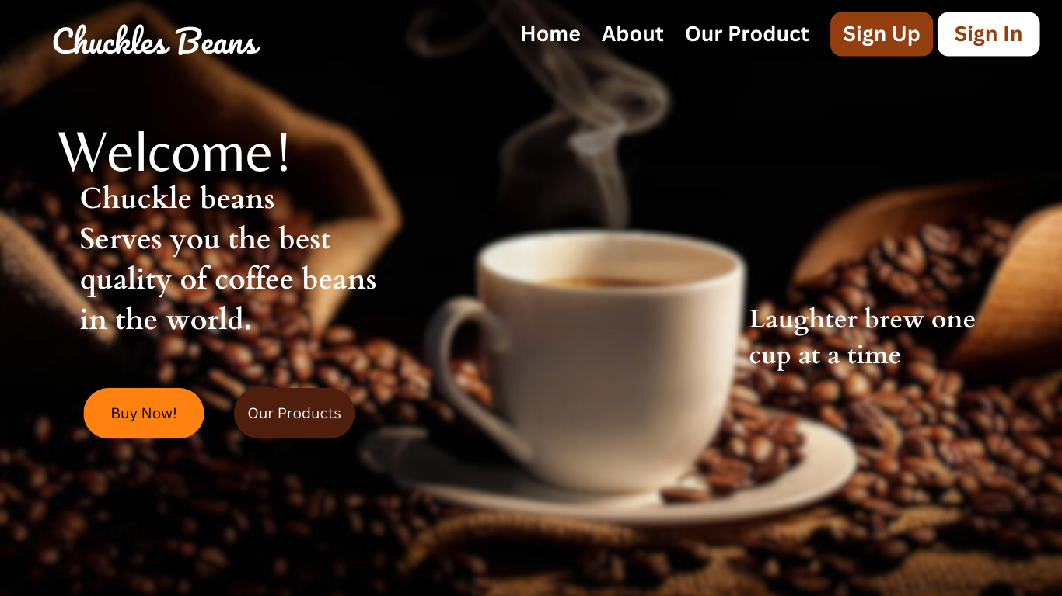
Layouts for the Website

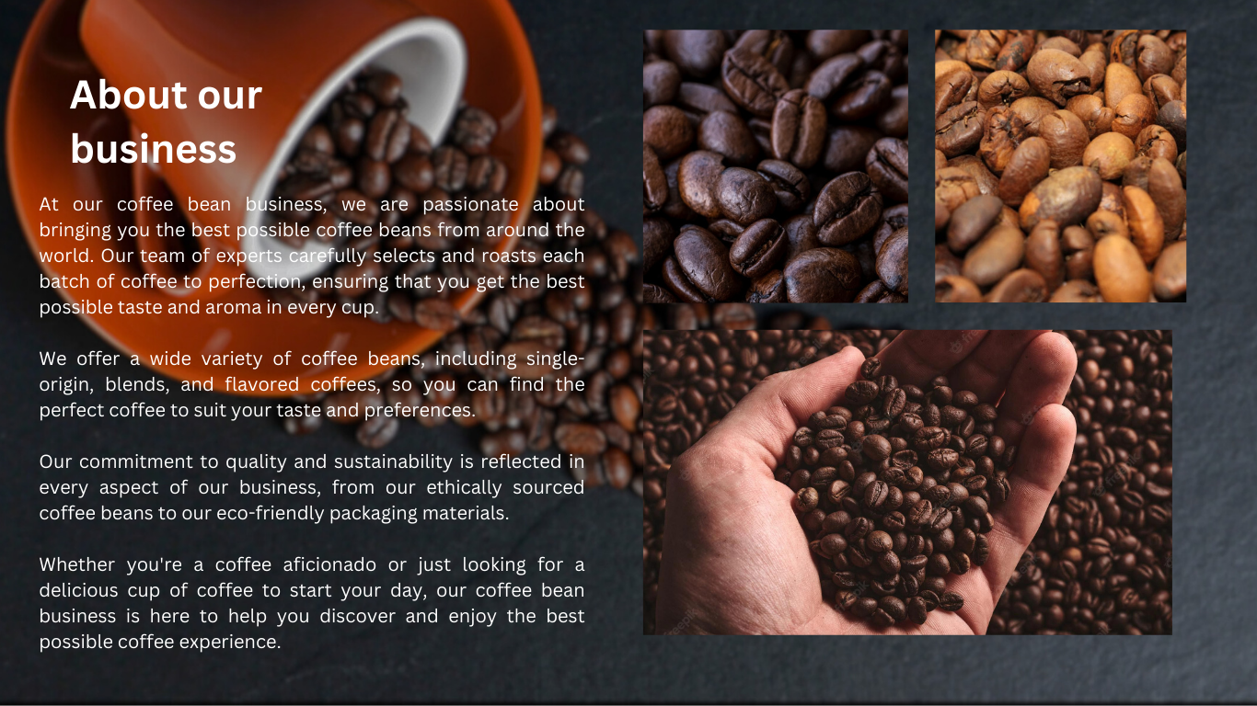

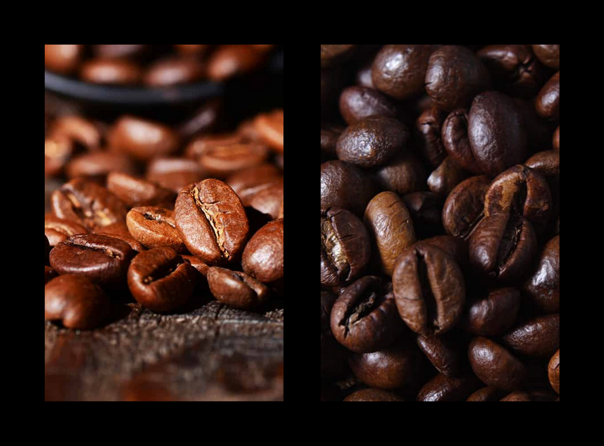
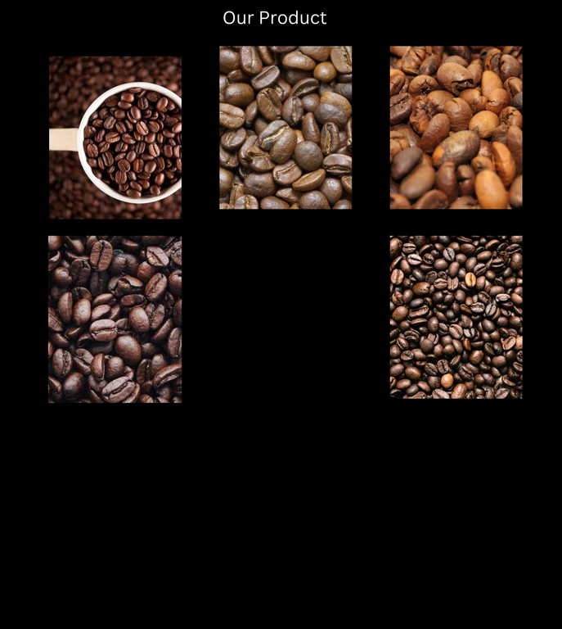

We utilize Canva for creating the layout of our landing page to provide clear instructions to our coder, facilitating easier coding management and ensuring consistent color choices for our websites.
Flow of our website
1. Sign in or sign up
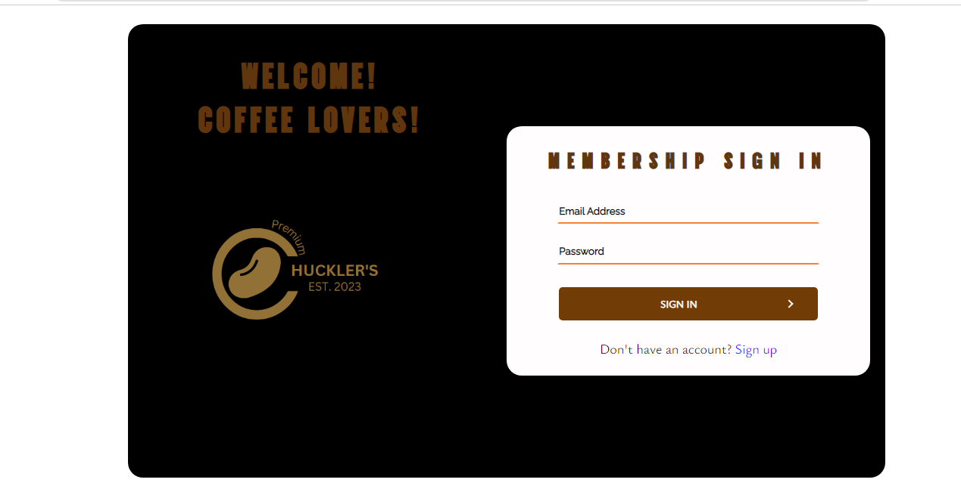
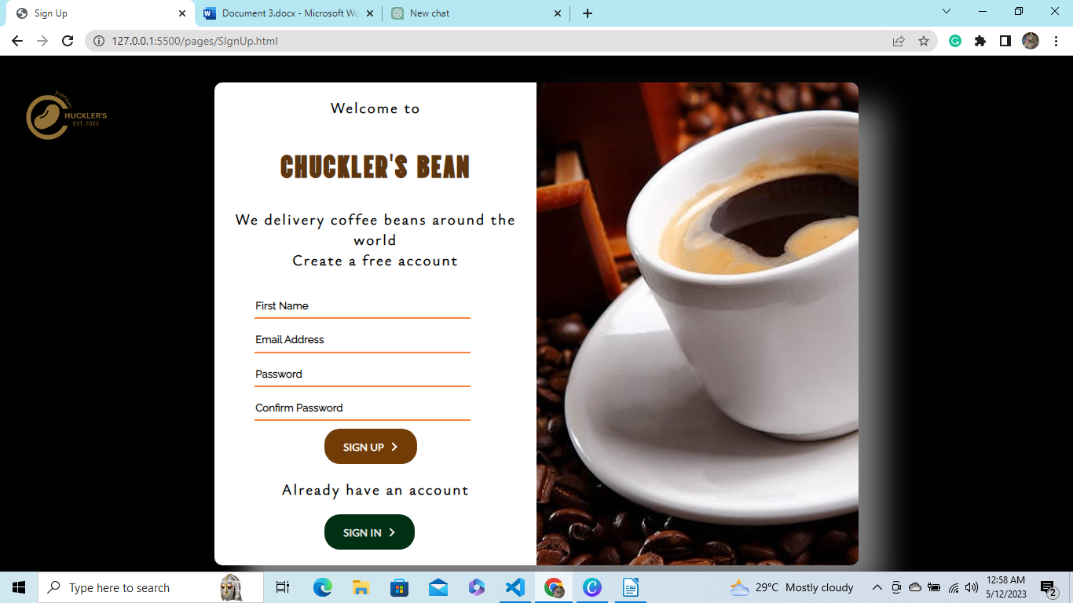

2. Landing Page
After the user sucessfully sign in or sign up, he will direct to the landing page of the webpage
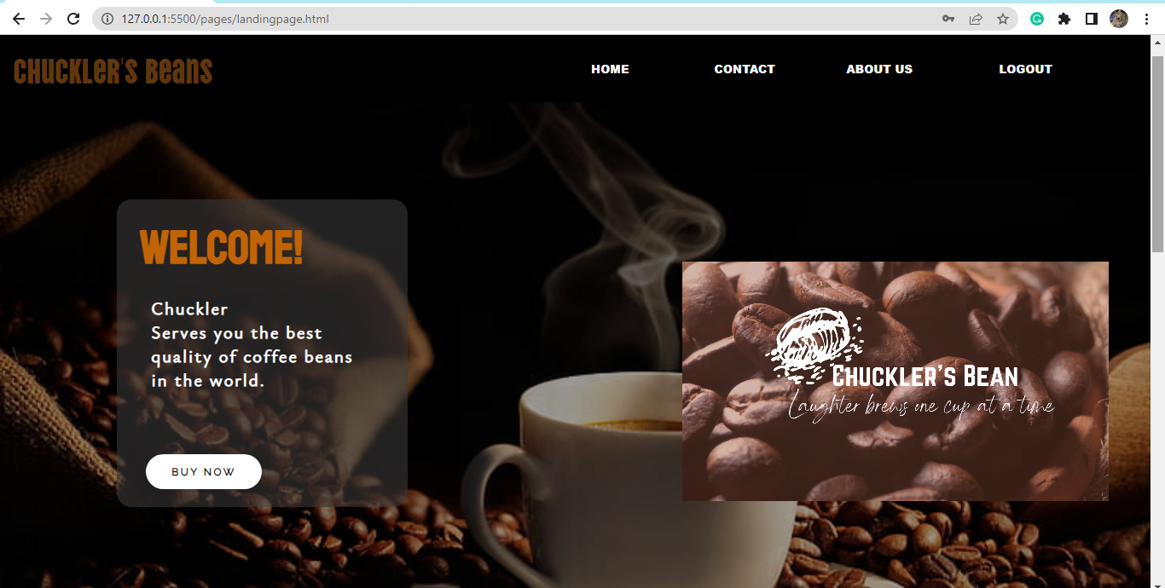
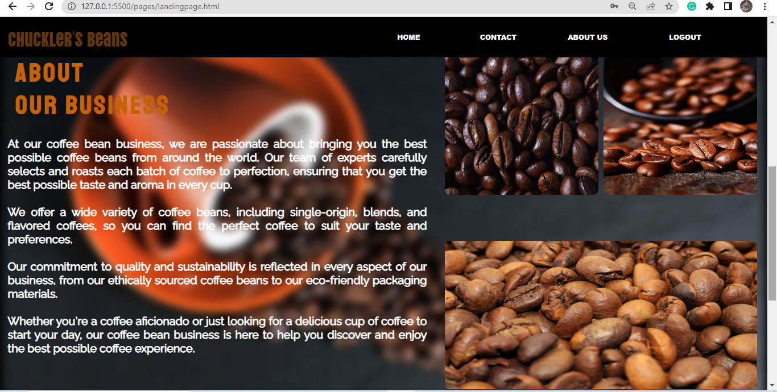
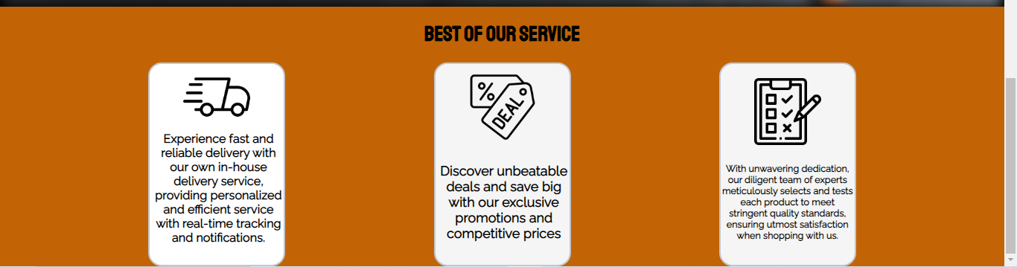

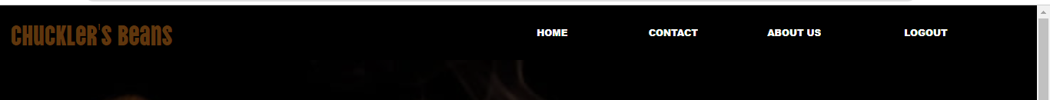
This is the navigation bar where you can navigate different section of the page, the HOME will drag you to the first page of the landing page.
At the navbar the after clicking the CONTACT button you will directly go to the contact page. Where you can contact us.
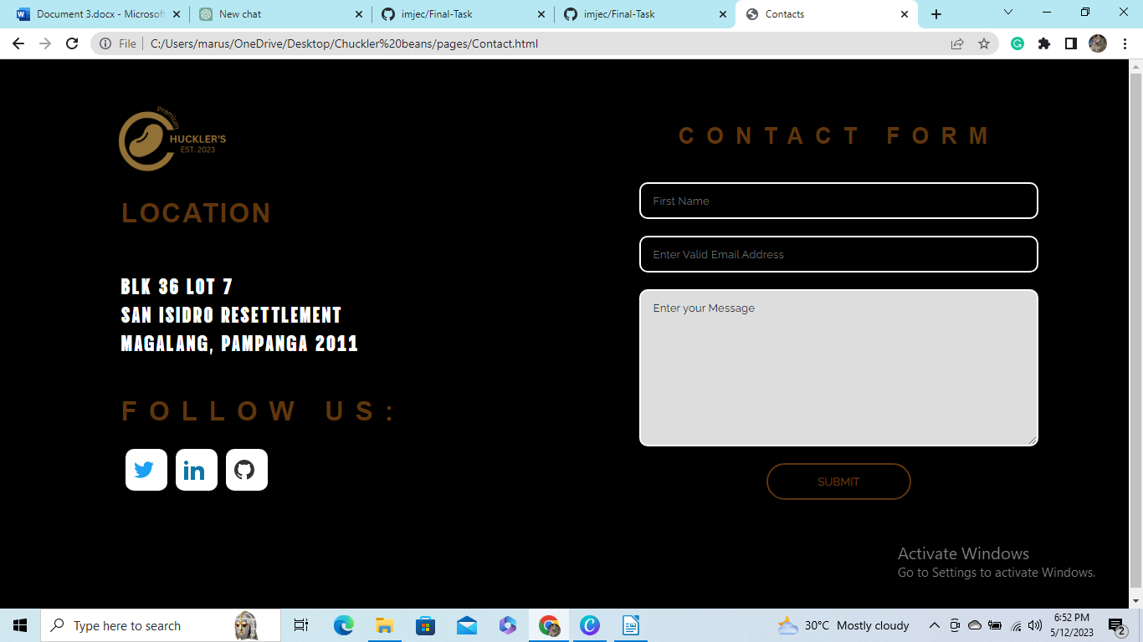
Clicking the logo will go back to the landing page of the website

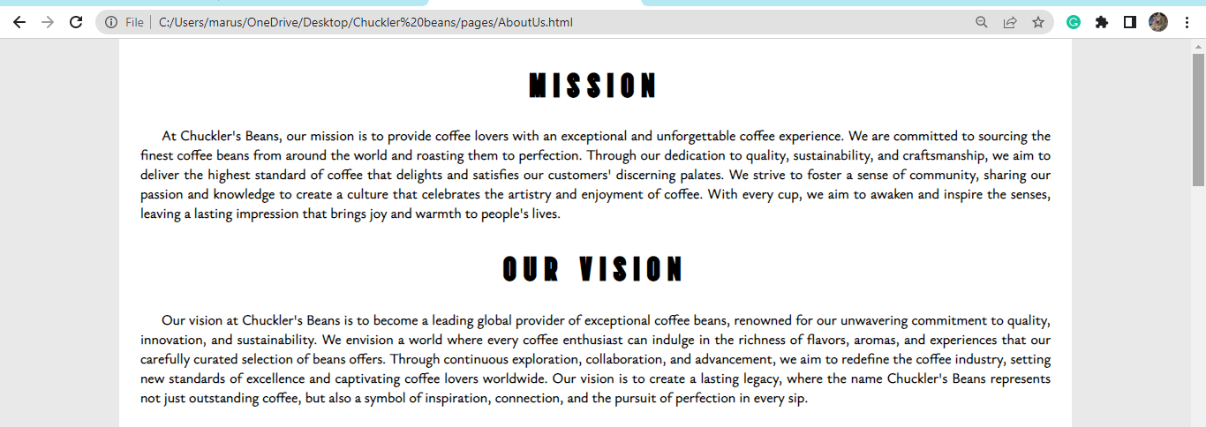
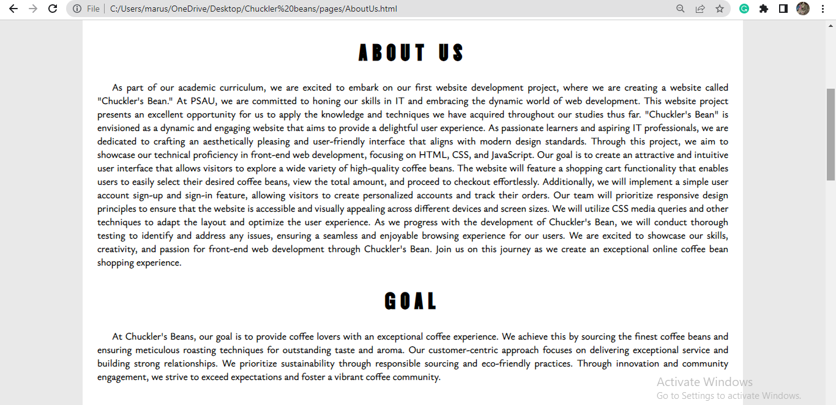
The about us in the navbar will direct you to our about us page, where you can see the MISSION, VISION, GOAL AND ABOUT US. And additionally in about us you can see our members and there respective social media accounts.

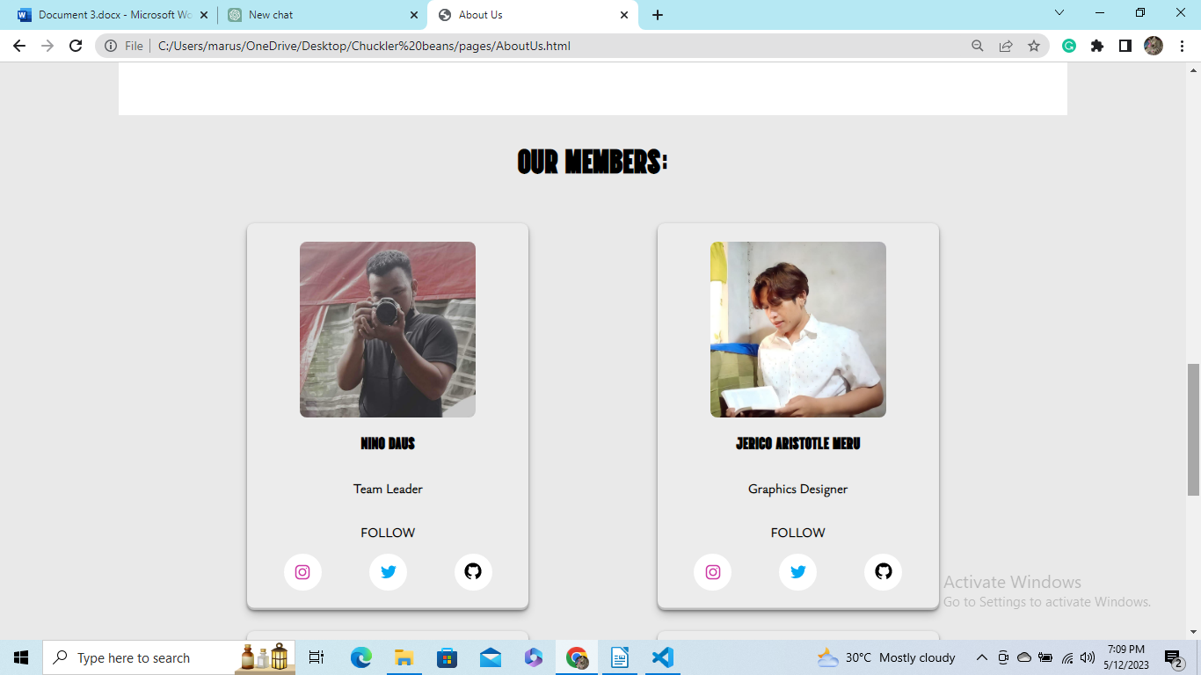
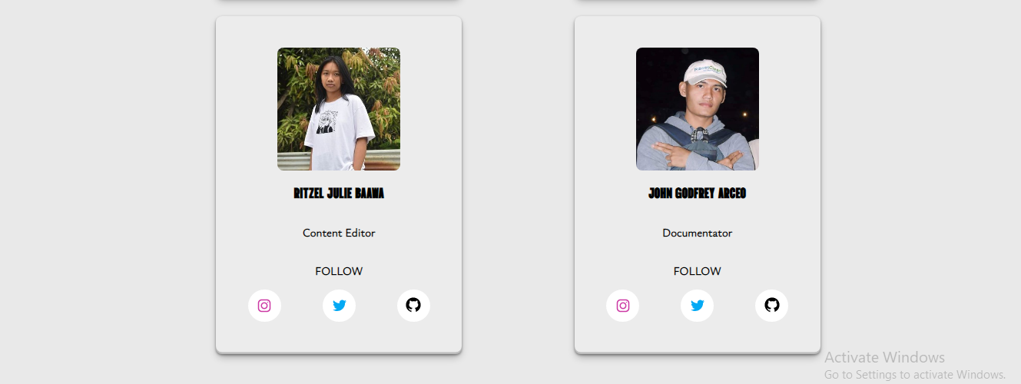
Then you can use the BACK ARROW on the top, to go back to the landing page of the website.
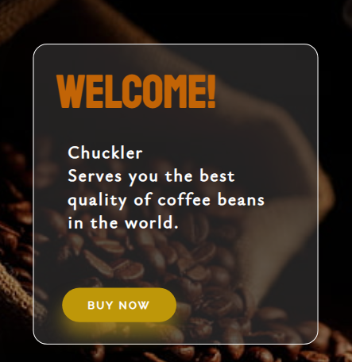
At the landing page of the website. You can see the BUY button. After clicking the buy button you will direct to our next page of the website.

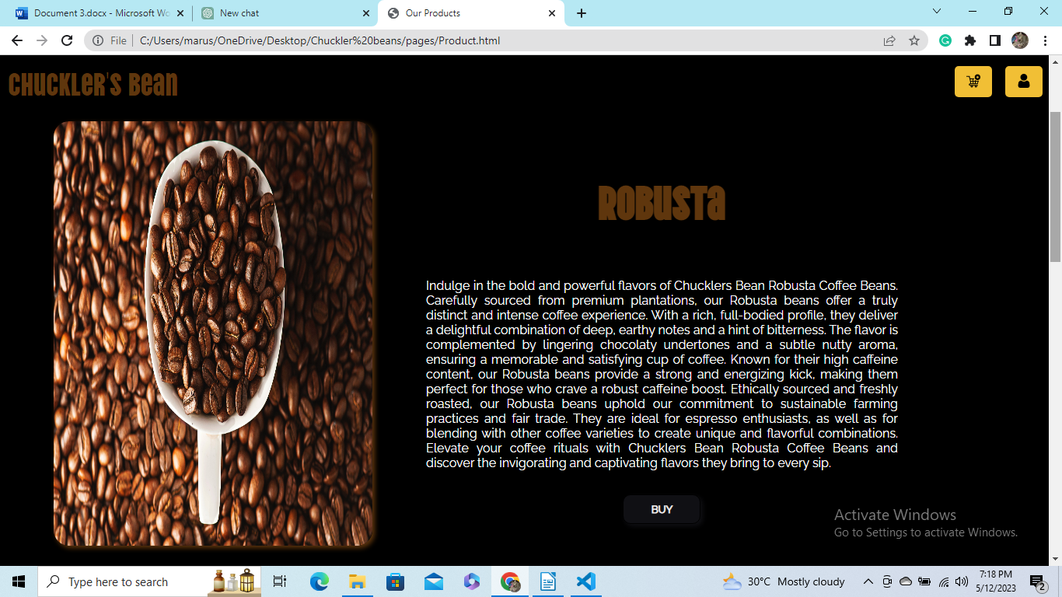
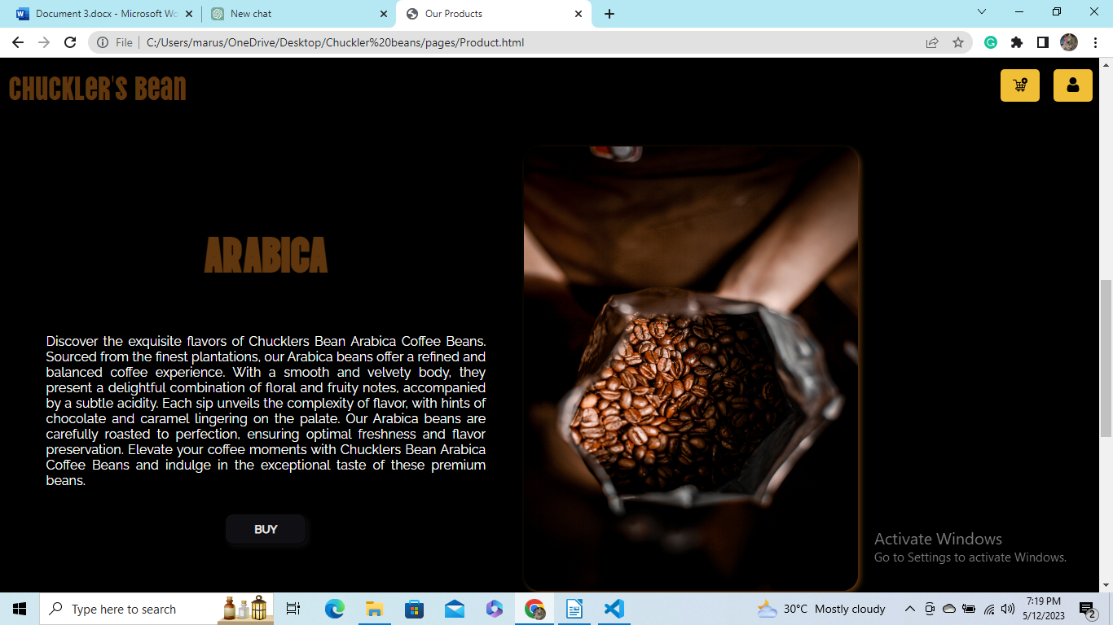

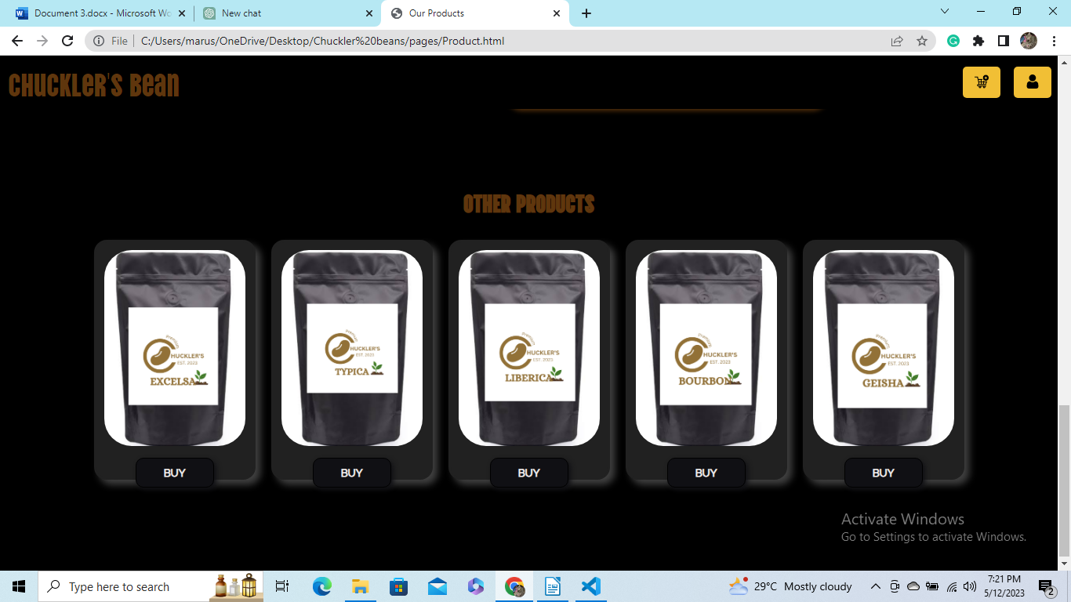
At this page you can see our Best selling products and other products where you can buy different kinds of coffee beans.
Clicking the cart button to the navbar will direct you to the shopping cart of the website where you can checkout your coffee products
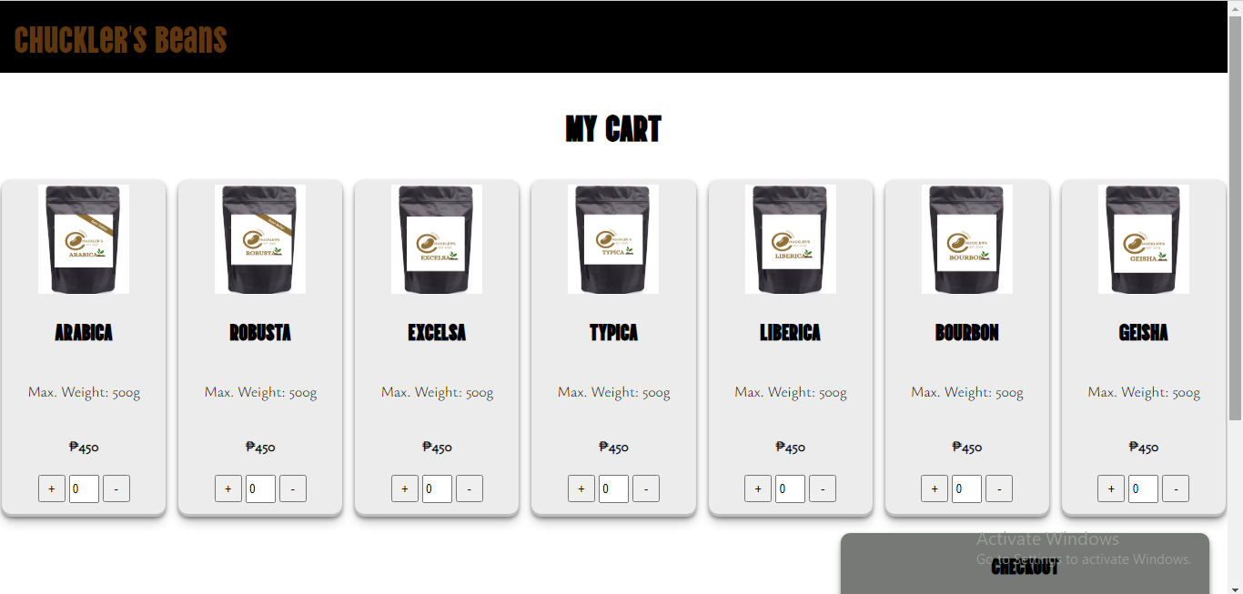

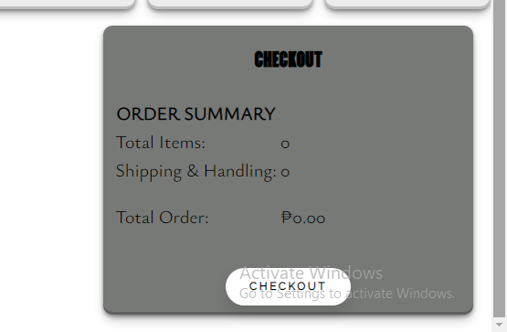

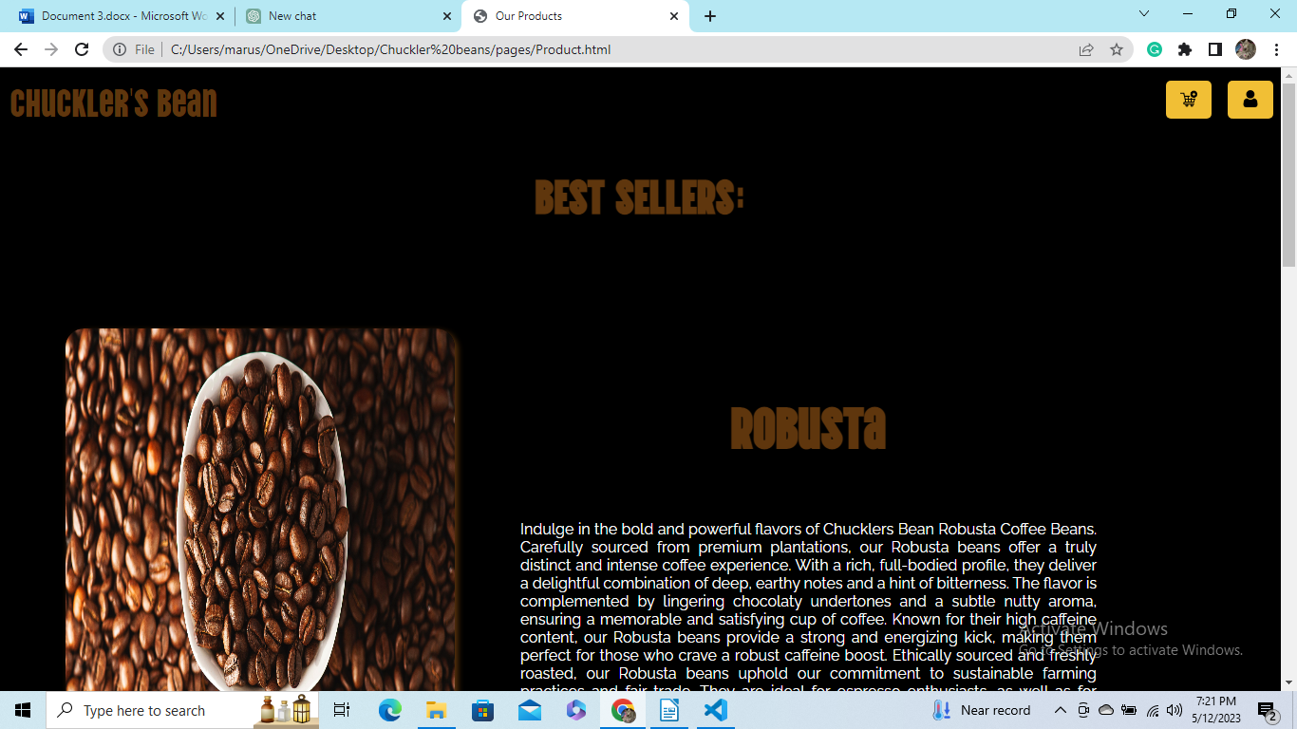

By click clicking this will go back to the landing page of our website.

This LOGOUT button on the navbar will logout your account and will go back to the SIGN IN page of our website.

5. Conclusion
This documentation provided an overview of the Chucklers Bean coffee beans website, focusing on its key features, architecture, and design aspects. The website utilizes HTML, CSS, and JavaScript to provide a straightforward and user-friendly shopping experience for coffee enthusiasts. With its shopping cart functionality and user account sign-up/sign-in, the Chucklers Bean website aims to simplify the purchasing process and provide a convenient way for users to manage their orders.

Overall the content of this website is finish, but our team is looking for upgrading this website in the near future where we can learned new things in our journey of being an IT student here at Pampanga State Agricultural University.

